java MyClass.java is valid from JDK11version—Both the compilation and execution will happen.

Collection of .class files we represent as Jar Files.

Main method : It is method from which JVM will start execution.

Private class Demo

{

Public static void main(String args[])

{

System.out.println(“Sai”)

}

}

---Class Which contains main () method should be declared as public.

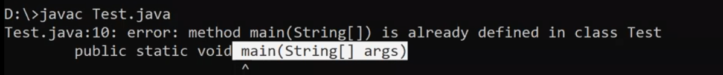

When we have more than one main method.Above Exception will occur during Compilation.

**byte** b='a';//The Ascii value of A will get stored in b